CFC Nutrient Ratio Templates Guide

A Nutrient Ratio Template is a pre-defined list of Nutrient Ratio Requirements. Once defined, a template may be added or merged into a Product Specification with a mouse click of a single command button, resulting in a significant time savings as compared to adding nutrient ratios to specifications one ratio at a time.

As Templates are added to the system, each is identified by an 8 character Template Code, along with a 40 character description. The system will allow the definition of an unlimited number of Templates.

Templates are added and maintained by selection of a menu item on the Concept5 Main Menu as follows:

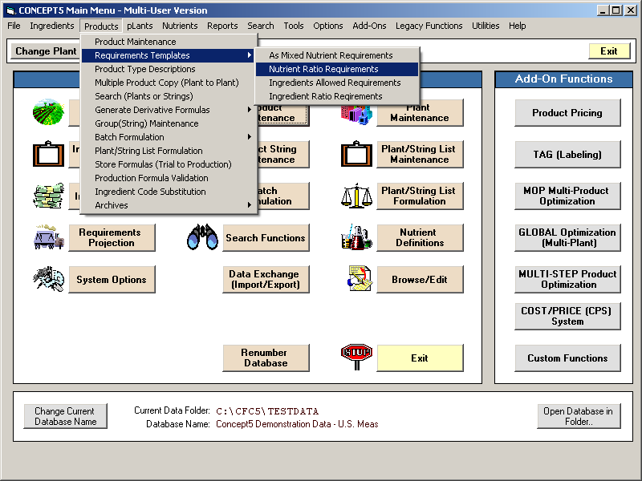
Creating/Editing Templates
After selection of the menu item from the Main Menu, the first Ratio Template in the database will be displayed. (If no Templates exist, you will be asked if you want to add a new Template.)

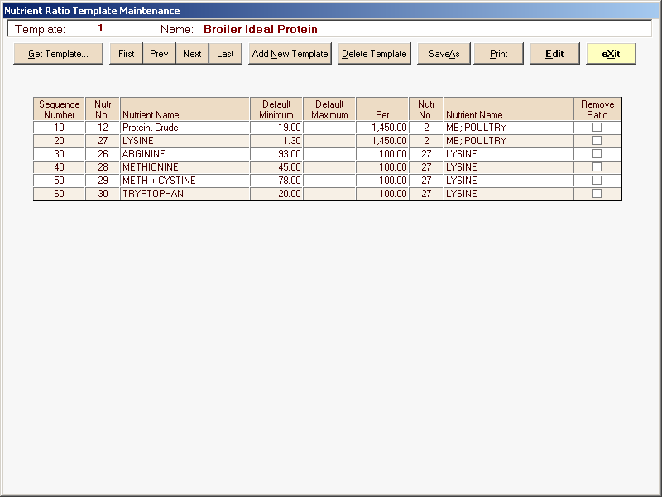

As the ratios included in the template are displayed on the screen, they are given a Sequence Number in increments of 10. If you click the “Edit” button, you may add more ratios, or change the limits of the existing ratios in the template. You may also change the Sequence Numbers of the ratios so that you may place them in a different order. When you save the changes to the ratios, they are resorted on the Sequence Number in ascending order before the template is saved back to the database.

The command buttons at the top of the screen are self-explanatory, and will not be discussed here in detail. They allow you to “Get” a specific template, scroll through all existing templates, add a new template, delete the template shown, save the template shown with a new template code, and print a hard copy of the template.

Templates can also be created by copying the nutrient ratio profile from an existing formula by clicking the Save Ratios as Template button found on the Nutrient Ratio tab of the Buffered Least Cost Formulation screen.

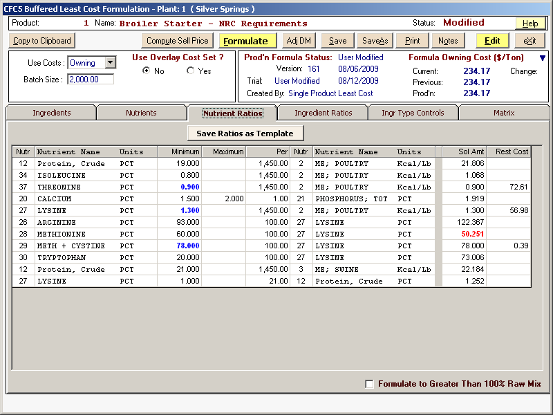

When this button is clicked a popup will appear requesting a template code number. Enter a code and a template will be created from the ratios shown. Request this template from the menu bar to edit the name.
Using Templates
A new Command button has been added to the “Nutrient Ratios” tab of the Full Screen Formulation screen (in Edit mode), with the caption “Load Ratios from Template”. When this button is clicked, an index of stored templates will appear so that you can select the desired template.

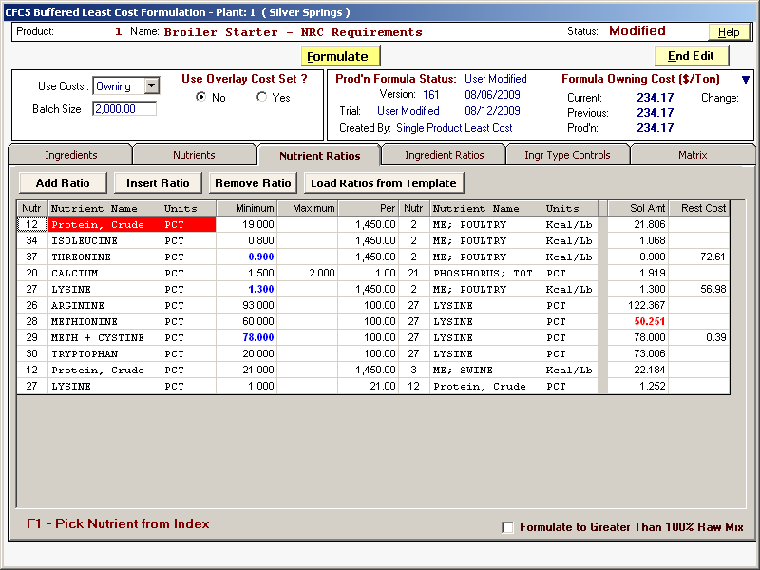

If there are no nutrient ratios already defined, all ratios from the selected Template will be automatically added to the product specifications, and will immediately appear on the Nutrient Ratios tab.
If one or more nutrient ratios already exist in the product specifications, an Options screen will appear as shown here:

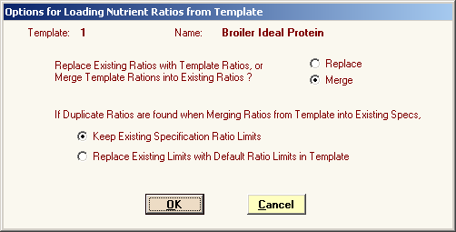

You may choose to Replace all existing ratios with the ratios defined in the selected Template, or you may Merge the ratios defined in the Template with the existing ratios in the product specification.

If you select Replace, all existing ratios will be deleted, then all ratios defined in the Template will be added back.

If you select Merge, the ratios defined in the template will be added to the ratios already existing in the product specification. You also have the option to keep the existing ratio limits, or replace the existing limits with the default limits defined in the Template for any duplicate ratios. All ratios defined in the template, but not in the existing specifications will be added to the end of the list of ratios and will be highlighted in yellow.

